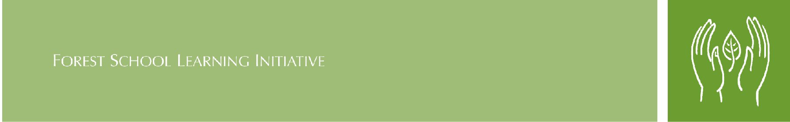

Forest School Medical Information Form

Childs Full Name

Date of Birth
Contact Name and relationship to child
Home Address

Phone number- | Home  Work  Mobile
Doctors | Address  Phone

Has your child had any of the following ?
Illness | Comment | Medication needed  Please specify
Asthma / Bronchitis
Sight or Hearing difficulties
Heart condition
Diabetes
Epilepsy
Allergies, eg pollen , nuts, materials, animals
Has your child ever been stung by a wasp or bee ?

If your child has any allergies, please describe the reaction they will experience and any symptoms we should look out for:

…………………………………………………………………………………………………

………………………………………………………………………………………..………..

Signature of parent/guardian……………………………..……………Date……………

