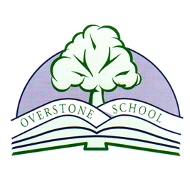
PLEASE COMPLETE AND RETURN TO SCHOOL
Food experience permission form 2020/21
Dear Parents/Carers
From time to time the curriculum may require children to try food in school. For example, bread making or trying seasonal fruits
We would be grateful if you could complete the following form and return it to school.

I give permission for my child _____________________________________ in class _____________ to participate in food related activities relating to the national curriculum and when in forest school.
or
I DO NOT give permission for my child _____________________________ in class ____________ to participate in food related activities relating to the national curriculum and when in forest school.
Please also tick one of the following:
My child DOES NOT have a food allergy or dietary restriction.
My child DOES have a food allergy or dietary restriction. He or she may participate, but may not eat or handle the following items (please list)
My child DOES have a food allergy or dietary restriction. He or she may NOT participate in the activities.
Parental signature ________________________ Date __________________________

