Special Diets Form - Information about my child's special diet
Please fill in this form in BLOCK CAPITALS and return it to your child's school.
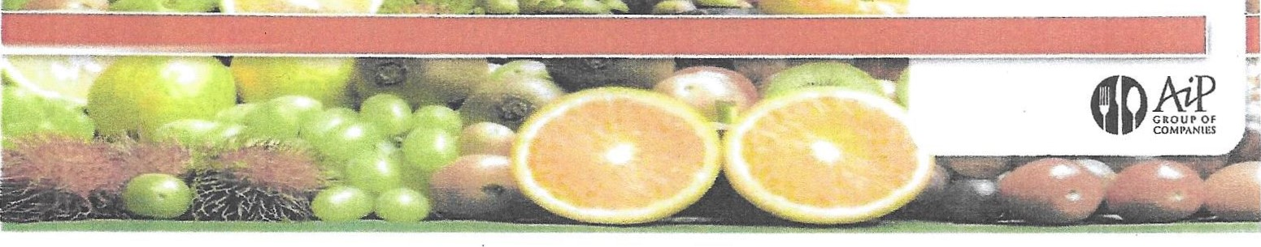
(The letter that goes with it tells you how)
Child's full name
School Name, Class, form and tutor
Your name
Your relationship to the child
Section B: Declaration
I confirm my child has a food allergy, intolerance or other dietary-related medical condition that needs addressing. The information in this form isn't about my child's food preferences.
I agree to information about my child's allergy and any related doctor's or registered dietician's medical assessment being provided to the school's catering partner AiP Group of Companies (including any other relevant personal data, like photographs, if I've agreed with the school), solely so they can provide the right alternative meals for my child.
Parent or guardian's signature
Date
Section C: Allergy details
Does your child have a food allergy? If YES, fill in this section. If NO go to Section D. | Tick if  YES | Please include as much information as possible about your child's food allergy in the space below. For example:  - Can they tolerate products that say •may contain traces'?  - Should they avoid all forms of the allergen - or can they tolerate some forms, for example raw, baked or cooked? If possible, please provide a copy of any relevant medical assessment or confirmation
celery
Cereals (containing gluten)
Crustaceans
Egg
Milk
Molluscs
Fish
List continues on next page
